MPPG #5 Profile Comparison Tool (v2.2) Instruction for Use

1. Introduction
2. Scanning Measurements
   1. Overview
   2. Supported Scanning Systems
   3. Supported Export Formats
   4. Notes on Scan Export
3. Treatment Planning System Calculations
   1. Overview
   2. Water Phantom
   3. Scanning Tank Origin Location
   4. Setting the Dose Grid
   5. DICOM Export
4. Use of the MPPG #5 Profile Comparison Tool
   1. Loading Measurement Data
   2. Loading Calculation Data
   3. Edit the DICOM Offset
   4. Running the Profile Analysis
   5. Depth-Dose and Profile Normalization Options
   6. Gamma Analysis Options
   7. Output Options
5. About the MPPG #5 Profile Comparison Tool

**SECTION 1: Introduction**

The MPPG #5 Profile Comparison Tool is a simple but powerful profile comparison tool designed to be used during the commissioning and QA of external beam treatment planning systems (Figure 1.1). The program accepts profile data from scanning water tank systems and DICOM-RT DOSE files from commercial treatment planning system, co-registers the data sets, and performs a 1D gamma analysis on the profiles. The user may specify a number of analysis and export settings.

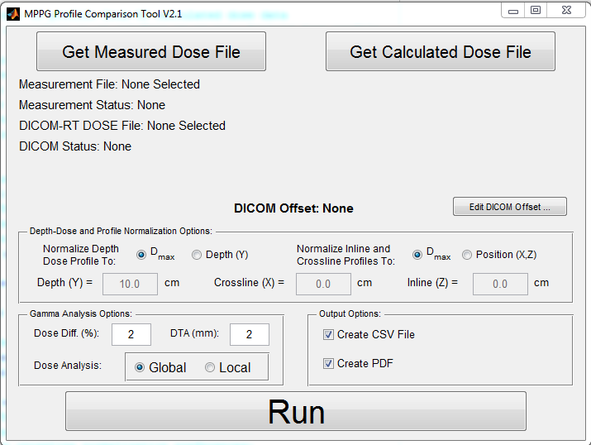  
Figure 1.1: The MPPG #5 Profile Comparison Tool Interface

**SECTION 2: Scanning Measurements**

**2.A Overview**

The MPPG #5 Profile Comparison Tool can be used whenever water-tank scans are taken for commissioning or QA purposes. The tool was designed with the AAPM MPPG #5 tests in mind, but may be used throughout commissioning process and during annual QA scans. The tool can be used to analyze linear scans of any kind, including depth-dose curves, inline profiles, crossline profiles and diagonal scans.

**2.B Supported Scanning Systems**

The MPPG #5 Profile Comparison Tool has been tested with the following scanning tank systems:

* IBA Blue Phantom 2 & OmniPro-Accept Software

Additional scanning systems may be supported. Support will depend on how the coordinate system is defined in the scanning software. It will also depend on the available file export formats.

**2.C Supported Export Formats**

The MPPG #5 Profile Comparison Tool accepts scanning data in the w2CAD format. This is the data export format for the widely used Varian Eclipse Treatment Planning system and it is expected most users of the tool have scanning software that will be able to export to this format.

The tool also accepts scanning data in the proprietary ASCII export format used by OmniPro-Accept.

**2.D Notes on Scan Export**

* The coordinate system used in w2CAD is based on the IEC-61217 standard (Figure 2.1), where the crossline direction is X, the inline direction is Y, and the depth direction is Z. The MPPG #5 Profile Comparison Tool expects the *measured* data to have this orientation.
  + Note: DICOM uses a different coordinate system. This is taken into account by the tool.
* The units used in w2CAD for position are millimeters. The MPPG #5 Profile Comparison Tool expects measured data to be in units of millimeters. Data is converted to centimeters upon import.
* The MPPG #5 Profile Comparison Tool performs comparisons between measured and calculated data using a combination of one exported measurement file and one DICOM-RT DOSE file at a time. We recommend that each measurement file and DICOM-RT DOSE file contain data corresponding to a single beam. For the measured data export, all the inline, crossline, depth dose and diagonal profiles from a single beam can be exported into a single file and analyzed at the same time. Please see section 3.E for more information on DICOM-RT DOSE export.
* Make note of the scanning tank origin [the (0, 0, 0) location] used by your scanning system. This location will need to be reproduced in the treatment planning system.



+ Inline (Y)

+ Crossline (X)

+ Depth (Z)

Figure 2.1: Coordinate system used for measured data (courtesy of OmniPro-Accept User's Guide Version 7.1a, IBA Dosimetry)

**SECTION 3: Treatment Planning System Calculations**

**3.A Overview**

The MPPG #5 Profile Comparison Tool compares the scanning tank data generated by the user to calculated dose profiles from the user’s treatment planning system. The tool accepts 3D DICOM RT-DOSE files and automatically extracts the required 1D dose profiles from the 3D dose distribution.

**3.B Water Phantom**

A water phantom must be created in the treatment planning system. This can generally accomplished using an empty CT dataset and the TPS contouring tools.

1. Create a new structure and draw a large rectangular box on a single CT slice.
2. Copy the box-shaped contour to a distant slice.
3. Use the TPS interpolation tools to fill the intervening slices.
4. The resulting rectangular box will be used as a virtual water phantom. Before proceeding, check the following:
   1. Is the phantom large enough? It must be large enough to provide sufficient scatter for all fields measured. Be sure to consider the maximum field sizes and depths that you will measure.
   2. Is the surface of the phantom flat and parallel to the coronal plane? If the surface of the phantom is not drawn level, there may be systematic differences between scans and calculated profiles.
5. Finally, the density of the phantom structure must be overridden to water.
   1. For Pinnacle3, the density of the structure may be overridden to 1.00 g/cm3.
   2. For Eclipse AAA, the HU value can be manipulated until a density of 1.00 g/cm3 is found. Alternatively, you may use the “Assign Material” option and select “Water”.
   3. For Eclipse Acuros, you must use the “Assign Material” option and select “Water”.
   4. For other treatment planning systems, please consult the instruction manual.

**3.C Scanning Tank Origin Location**

In order to perform profile comparisons, MPPG #5 Profile Comparison Tool must know the relationship between the DICOM coordinate system in the treatment planning system and the scanning tank coordinate system. The relationship between these two coordinates systems can be determined by specifying the scanning tank origin location in the treatment planning system. The DICOM coordinates of the scanning tank origin is called the *DICOM offset*.

The DICOM offset helps the MPPG #5 Profile Comparison Tool determine the relationship between the origin of the coordinate system used in the DICOM-RT DOSE file and the origin of the coordinates used in the scanning tank measurements. This allows the measured and calculated dose profiles to be compared in terms of their absolute location rather than a relative location.

The DICOM offset is defined as the shifts in X (left-right), Y (anterior-posterior) and Z (superior-inferior) that you would have to make to move from the DICOM origin to the scanning tank measurement origin. There are two ways to obtain the DICOM offset:

Automatically Detect DICOM Offset

The MPPG #5 Profile Comparison Tool will automatically determine the DICOM offset if a Point of Interest (Pinnacle3) or a Reference Point (Varian Eclipse) is created for the scanning tank origin in the treatment planning system.

1. Create a Point of Interest/Reference Point in your treatment planning system called “ORIGIN” (all caps).
2. Move this point to the location of the scanning tank origin. See Figure 3.1 and 3.2 for two examples.
3. When exporting the dose distribution, additional files will need to be exported:
   * For Varian Eclipse: The DICOM-RT PLAN will need to be exported with the DICOM-RT DOSE files.
   * For Pinnacle3: The DICOM-RT PLAN and DICOM-RT STRUCT will need to be exported with the DICOM-RT DOSE files.

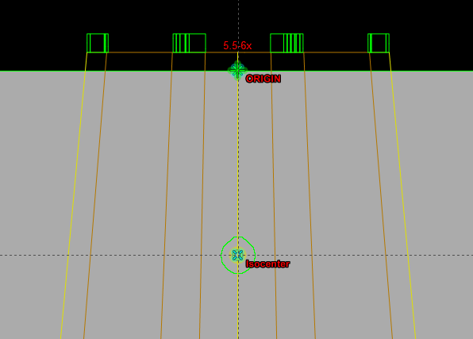

Figure 3.1: Setting the scanning tank origin using a Reference Point called “ORIGIN” for an AP field.

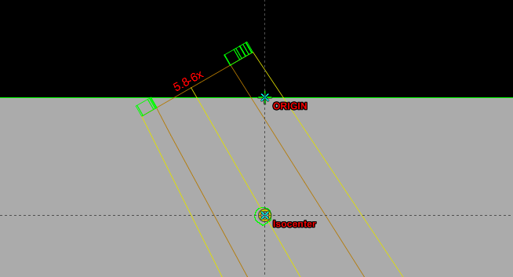

Figure 3.2: Setting the scanning tank origin using a Reference Point called “ORIGIN” for an oblique field.

Manually Enter DICOM Offset

The DICOM offset may be entered manually into the MPPG #5 Profile Comparison Tool. How to enter it in the tool is discussed in Section 4.B and 4.C. The DICOM offset can be found in the treatment planning system:

Varian Eclipse: Move the User Origin to the location of the scanning tank origin. Right click “User Origin” and select “Set User Origin…”. The DICOM offset can be read from the Set User Origin window (Figure 3.3).

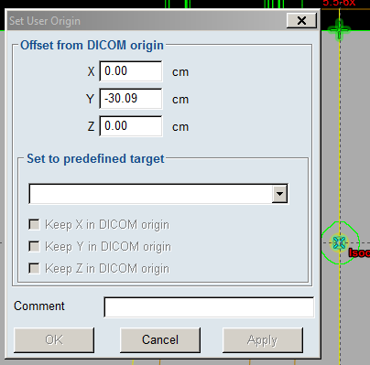  
Figure 3.3: The DICOM offset in Varian Eclipse

Pinnacle3: Create a “Point of Interest” and move this point to the location of the scanning tank origin. The DICOM offset can be read under “DICOM Coordinates” in the “Points” window (Figure 3.4). The coordinates may be given in millimeters and will need to be converted to centimeters before entering them in the MPPG #5 Profile Comparison Tool.

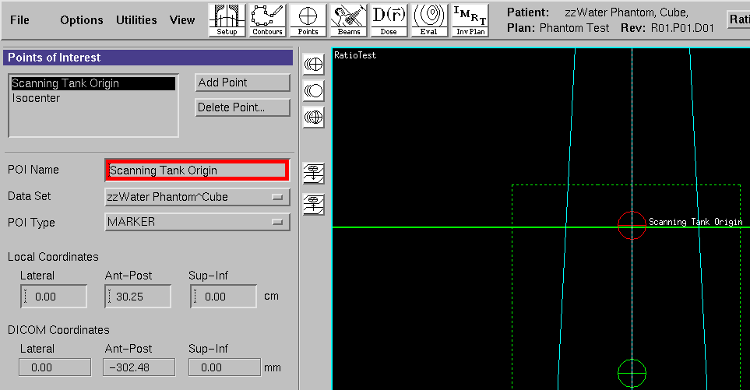  
Figure 3.4: The DICOM offset in Pinnacle3

**3.D Setting the Dose Grid**

* The dose grid must be large enough to encompass all of the scans. If it is smaller than the scans, the MPPG #5 Profile Comparison Tool will still perform an analysis on a truncated dataset, but will give a warning to the user.
* The dose grid resolution may be set to any value. Finer resolution grids result in larger DICOM-RT DOSE files. However, a finer grid resolution may improve agreement with the measured profiles in high gradient regions.
* A systematic shift in the depth dose profiles may be seen for larger grid resolutions. The maximum shift is one-half the dose grid resolution. The origin of this effect seems to be interplay between the location of the water phantom surface and the location of the dose grid voxels near the surface. The effect of this interplay is minimized for smaller dose grid resolutions.

**3.E DICOM-RT DOSE Export**

* The DICOM RT-DOSE that is exported must be a 3D dose grid, not a 2D planar dose.
* The DICOM RT-DOSE may be exported as dose-per-beam or plan dose. Exporting using dose-per-beam allows efficient export of a number of fields simultaneously.
* A DICOM Renamer Tool is included with the MPPG #5 Profile Comparison Tool. This tool automatically renames DICOM-RT files by their plan name and beam name. This only works for dose-per-beam export and requires the DICOM-RT PLAN file.
* If you choose to have the MPPG #5 Profile Comparison Tool automatically determine the DICOM offset:
  + For Varian Eclipse: The DICOM-RT PLAN will need to be exported with the DICOM-RT DOSE files. A reference point called “ORIGIN” must be created in the plan at the scanning tank origin (section 3.C**).**
  + For Pinnacle3: The DICOM-RT PLAN and DICOM-RT STRUCT will need to be exported with the DICOM-RT DOSE files. A point of interest called “ORIGIN” must be created in the plan at the scanning tank origin (section 3.C**)**.

**SECTION 4: Use of the MPPG #5 Profile Comparison Tool**

**4.A Loading Measurement Data**

To load measured scans, click the “Get Measured Dose File” button. The “Select Measured Data” window will open. By default, only files with the ‘.ASC’ extension will be shown. Select a file and click “Open”.

After a brief loading period, the text next to “Measurement File” and “Measurement Status” will change. The “Measurement File” line will display the measured dose filename. The “Measurement Status” will summarize the contents of the measured dose file (Figure 4.1).

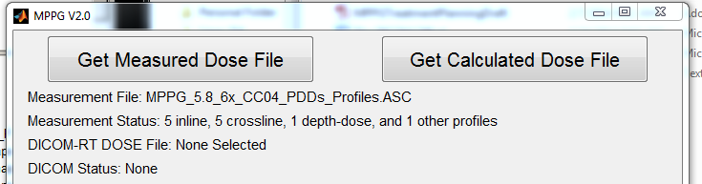  
Figure 4.1: The main window after loading measured data

**4.B Loading Calculation Data**

To load a calculated DICOM-RT DOSE file, click the “Get Calculated Dose File” button. The “Select DICOM-RT Dose File” window will open. By default, only files with the ‘.dcm’ extension will be shown. Select a file and click “Open”.

After a brief loading period, the text next to “DICOM-RT DOSE File” and “DICOM Status” will change. The “DICOM-RT DOSE File” line will display the measured dose filename. The “DICOM Status” will describe the loading process and whether it was successful in automatically finding the DICOM offset (Figure 4.2).

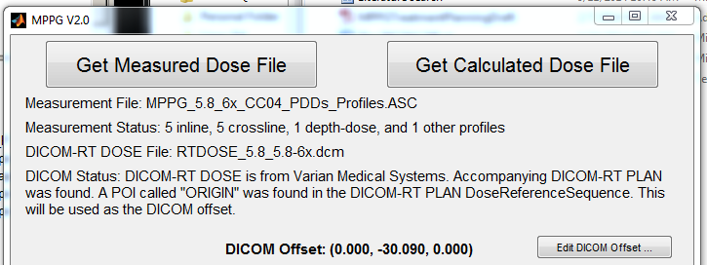  
Figure 4.2: The main window after loading a DICOM-RT DOSE file. The DICOM offset was automatically determined.

The MPPG #5 Profile Comparison Tool will attempt to determine the DICOM Offset automatically using other files in the same directory. If the required files are in the same directory and point called “ORIGIN” was created in the TPS, the offset will be extracted from these files automatically. If not, the “Enter DICOM Offset…” box will appear and allow you to enter the DICOM offset manually (Figure 4.3).

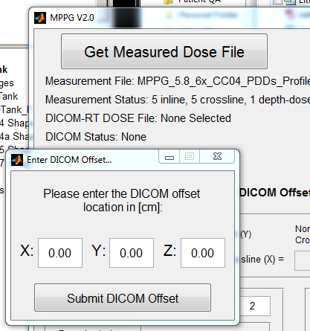  
Figure 4.3: The “Enter DICOM Offset…” Window

**4.C Edit the DICOM Offset**

If you wish to change the DICOM offset after the DICOM-RT DOSE file has been loaded, click the “Edit DICOM Offset…” button. The “Enter DICOM Offset…” box will appear and allow you to enter the DICOM offset manually.

**4.D Running the Profile Analysis**

To compare the measured profiles to the calculated data in the DICOM-RT DOSE file, click the “Run” button (Figure 4.4).

Figure 4.4: The “Run” button

**4.E Depth-Dose and Profile Normalization Options**

There are a number of profile normalization options available. Normalization options may be set separately for depth dose profiles and inline/crossline profiles (Figure 4.5).

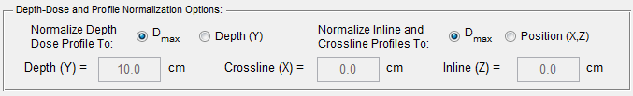  
Figure 4.5: The Depth-Dose and Profile Normalization Options box

* Normalize Depth Dose Profile To:
  + Dmax: The measured and calculated depth dose profiles are rescaled such that that maximum dose for each profile is 1.
  + Depth (Y): When the user selects this option, the box next to “Depth (Y) =” becomes editable. The user may enter a normalization depth in the box. The profiles will be normalized to the same value at this depth. After normalization at depth, both profiles are rescaled by the same factor so that the measured profile maximum dose has a relative value of 1.
* Normalize Inline and Crossline Profile To:
  + Dmax: The measured and calculated dose profiles are rescaled such that that maximum dose for each profile is 1.
  + Position (X,Z): When the user selects this option, the boxes next to “Crossline (X) =” and “Inline (Z) =” becomes editable. The user may enter a normalization location in the box.
    - For crossline profiles, the measured and calculated dose profiles will be normalized to the same value at the location in the “Crossline (X) =” box.
    - For inline profiles, the measured and calculated dose profiles will be normalized to the same value at the location in the “Inline (Z) =” box.
    - After normalization at a given position, both profiles are rescaled by the same factor so that the measured profile dose maximum has a relative value of 1.

For diagonal profiles:

* If there is any change in depth, the depth-dose options will apply
* If there is no change in depth, the diagonal profile will use the crossline profile options.

**4.F Gamma Analysis Options**

The gamma analysis criteria may be specified in the “Gamma Analysis Options” box. (Figure 4.6).

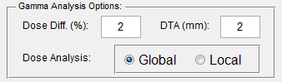  
Figure 4.6: Gamma Analysis Options box

* Dose Diff. (%): The dose difference criterion for gamma analysis
* DTA (mm): The distance-to-agreement criterion for gamma analysis
* Dose Analysis:
  + Global: The dose difference percentage will be calculated relative to the maximum measured dose in the profile.
  + Local: The dose difference percentage will be calculated relative to the local measured dose value.

**4.G Output Options**

The program produces two kinds of output. They may be turned on and off in the “Output Options” box (Figure 4.7).

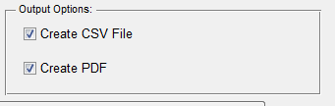

Figure 4.7: Output Options box

* Create CSV File: A comma-separated value file called “mppg_out_table.csv” will be created. The file contains a log of each profile analyzed. Each entry includes filenames, scan axis, measurement depth and results of the gamma analysis.
* Create PDF: Figures will be created for each profile analyzed and saved as a PostScript file. The user may convert this to a PDF. The figures contain a comparison of the measured and calculated profiles. They also show the gamma analysis value across the profile.

**SECTION 5: About the MPPG #5 Profile Comparison Tool**

The MPPG #5 Profile Comparison Tool was created as part of a multi-institution research collaboration. Jennifer Smilowitz, PhD, provided oversight over the project. Dustin Jacqmin, PhD, and Jeremy Bredfeldt, PhD, led the development of the tool. Jacob Hoberg, MS, Zac Labby, PhD, Bishnu Thapa, PhD and Nick Koch, PhD, provided valuable feedback during the development and testing process.